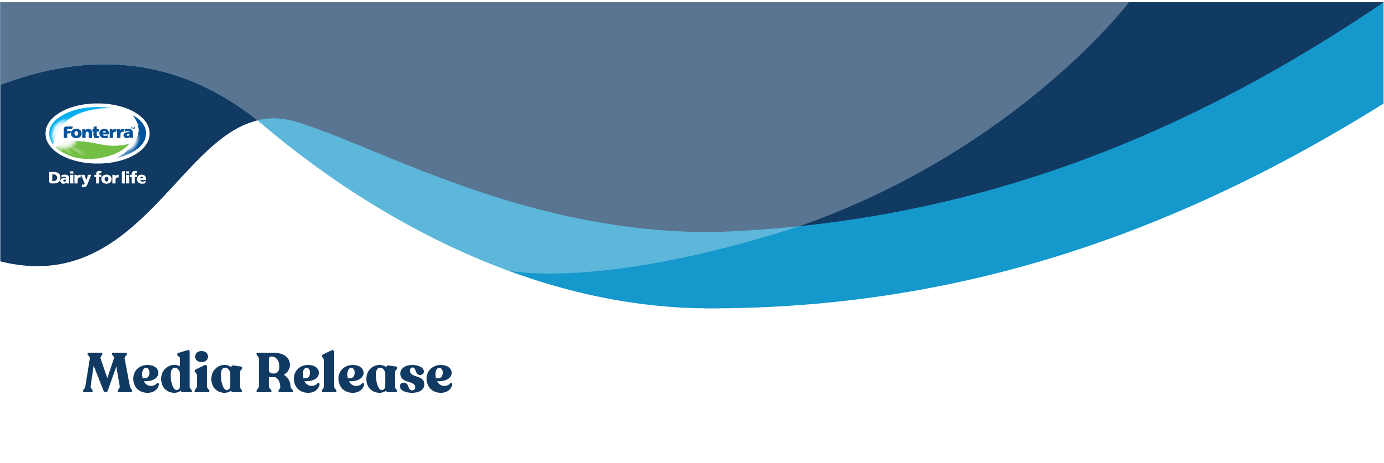

2 March 2020
NEW CHAPTER FOR DENNINGTON FACTORY

ProviCo Australia buys Fonterra’s Dennington site

Fonterra Australia and ProviCo Australia have signed a sale agreement for Fonterra’s Dennington manufacturing site. The sale will be complete by 22 April 2020.
ProviCo is an Australian-owned company established in 2003 and a leader in animal nutrition. It is Australia’s largest supplier of calf milk replacers, manufacturing a range of feed and vitamin fortified products for animals including cattle, dairy, sheep, horses and pigs.
Fonterra Australia Managing Director René Dedoncker said the sale is good news for Dennington and its surrounding community.
“Since we announced the factory’s closure in May, we’ve been working with potential buyers to find a commercially viable and sustainable future for the site, and we’re pleased to be selling the factory to ProviCo with all of its operational capabilities and assets intact.
“The sale creates a new chapter for the factory, which has been an important part of the Dennington community for more than 100 years,” said Mr Dedoncker.
Managing Director of ProviCo Australia, Andrew Paterson, said that the sale will create new jobs for the Dennington community and provide environmental benefits for the agriculture industry.
“Active in the circular economy, our business is focused on salvaging raw materials and turning them into animal nutrition products. This helps the food industry minimise their waste costs and ProviCo’s products improve farm performance and health of animals and soils.
“We’ll be employing local people and will work with local training institutions to provide on-the-job skills training to create further employment opportunities for the community.
“As well as creating local jobs, we’re committed to sustainability and sustainable initiatives are a big part of our plans. The Dennington site will be a hub for our sustainability programs around renewable energy and sustainable farming products,” said Mr Paterson.
ProviCo will use the site to manufacture a range of animal nutrition foods that deliver health and performance benefits for infant and production animals. As part of the sale agreement, ProviCo will also take over the responsibility of the Dennington memorabilia hall and its content.
The Dennington church and its hall are not included in the sale. Fonterra is in discussions with the Warrnambool Council on the future of the church and its hall and hopes to be able to communicate the outcome of these discussions soon.

- ENDS -

For further information contact:
Sarah Counsell  Fonterra Australia Communications  Mobile: 0438 482 370  sarah.counsell@fonterra.com | Andrew Paterson  ProviCo Australia Managing Director  Phone: 03-9394 3806  admin@provico.com.au

About Fonterra

We’re a global dairy nutrition company owned by 10,000 farmers and their families. We’ve built our expertise on the legacy of the thousands of farmers who’ve made New Zealand a world leader in dairy. With a can-do attitude and a collaborative spirit, we’re a world leading dairy exporter. Our 22,000 people share the goodness of dairy nutrition with the world through our innovative consumer, foodservice and ingredient solutions brands, and our farming and processing operations across four continents.
In Australia, Fonterra Australia operates six manufacturing sites across Victoria and Tasmania and employs around 1,500 people. We collect milk from Australian farmers, and this milk is made into the many Fonterra dairy foods that generations of Australians have grown up with and love, including Perfect Italiano™, Mainland™, Western Star™ and Anchor™. The business also sells dairy ingredients to many of the world’s leading food companies and it operates a dedicated sales channel for the foodservice industry, providing a full range of dairy products specifically designed for commercial kitchens.
About ProviCo

ProviCo Pty Ltd founded in 2003 is proudly 100 % Australian owned by people with generations of direct farm experience, we understand what Australian farmers need and how to assist them improve their farm productivity and animal and soil health. ProviCo is Australia’s largest manufacturer and supplier of premium quality animal nutrition milk replacers made with Australian dairy ingredients. ProviCo’s flagship ProfeLAC brand and vitamin fortified products are sold nationwide. ProviCo is known for its range of innovative products that deliver health and performance benefits for growing and production animals.

